**ANNUAL REPORTS**

**APRIL 2021 TO MARCH 2022**



**Wide Angle Social Development Organisation**

**Sagolband Moirang Hanuba Leirak**

**Wellness for Children during the Lockdown:**

Yoga Session for children was conducted from 26th to 28th May 2021 8am -9am with the Art of Living team atThambal Children Home Girls (CCI), Imphal West. We also tried to conduct such Yoga session at Government’s Observation Home, TakyelpatImphal, but due to non-availability of internet connection and closing of Social Welfare Dept and the Programme Officer herself being sick could not do the session, however it is in the planning.

**Relief Material**

There was a lot of children who are infected by Covid 19 in IW as well as parents. Parents who are not government employees and casual labour were got infected and staying at Covid Care center and hospitals for treatment and even there were children who lost parents. We the team of Wide Angle got request for seeking some support system from the community i.e., local club or AWWs to do something for those children. We have found that this time Childline 1098 Imphal West were supporting some ration to those children of casual labour parents. We referred details of those children to Childline and got support for 12 nos. of children with the ration of 3 kg of rice, 2kg of dal, 1 kg of onion and few vegetables. Further, for the month of June 21 we have collected details of all those needy by communicating local leaders, volunteers for referring them to 1098. As of now details of 22 nos. of children are ready to seek support for the ration from ChildLine.

Materials consisting of hand sanitizer, soup,mask, hand gloves, milk, tea, Mango and bread was provided at the Covid Care Center at THAU, Imphal on the 22nd May 2021.

The second wave of Covid 19 Pandemic is affecting the worst in Imphal West district of Manipur. As many lives are lost due to the disease and causing anxiety and depression with the illness being one of the major component.

**Mass Covid Testing**

Mass Covid Testing has been started as a Government initiative, and also by approaching to the Medical Directorate to conduct such testing, 9 villages of our intervention area has been reached, among the Covidpositive people there are about 34 children from the intervention area. The children are treated at their respective homes in isolation, no critical condition has been found with the children. The Wide Angle team is maintaining constant interaction over the phone with the VCPC, AWW, Club Member and Children from the Children Collective.

**Case Story:**

Anjali (name change), a 9 year old girl belonging toSagolband Moirang Hanuba which is also one of our village of the intervention area, who was provided with ration through ChildLine. She lost her father who committed suicide.Anjali theone and only child to her parents, studying in 3 Std is infected by Covid 19, havingserious illness highlighting fever, flu, cough etc. she was in home isolation as there was no Covid Care Center only for children in the State. She was staying in one separate room of the house alone. Her mother and father were in critical condition caring their child. The house also does not have a separate toilet. Her father, 45 years of aged who also had a history of treatment of depression, was very anxious of his child fearing serious complication would happen to his daughter. During such period one early morning, i.e., about 5 days of Anjali’s illness it is found that her father was hanging with a rope in their courtyard.

One particular Private School Kindergarten Montessori School pressurising parents to clear school fees for 2 months as to conduct the first assessment test of the academic year, children who were accessing online classes were to appear such exam. Meanwhile there was a notification of 6 students organization namely AMSU, MSF, DESAM, AIMS, SUK and MSF on 29th May that no fees should be taken by Schools authorities or pay by the parents and pressursing the Government for an order or notification regarding school fees by Private School during this critical pandemic or to continue with the notification given in the previous year for payment of 30% of the fees.

When we got information that school is taking full amount of fees from parents to appear the assessment test as answer sheets are provided only to those children who paid fees so for those children who did not clear their fees were not allowed to appear the assessment test. We had a communication with thestudents organizations to look after such matter of such school. The students organization had a meeting with the schools authority along with the president of the “ALL Manipur Private Schools Parents and Guardian Association” on 1st of June. The meeting declared that the children were allowed to appear exam now with or without the payment of the fees.

**PROGRAMME on VHND with AAA**

16th July Awareness on Covid Prevention, hesitancy on vaccination was conducted during the VHND programme along with ASHA, AWW at Maklang villages (11 members) and Salam Anganwadi center (11 members).

3 VHND programs were conducted during this month, on 6th , 7th and 10th of August at Maklang , Salam and at NgairangbamAwang and NgairangbamMakhaLeikai respectively, with 15 pregnant women and Lactating Mother at Maklang , 14 Pregnant women and Lactating Mother at Salam and 11 pregnant women and lactating Mother at NagirembamAwang and Makhaleikai, the programs focuses on the Awareness on Covid vaccination and preparedness of Covid third wave. 2 lactating mother from Maklang Village got benefited through JSY.

6th of Sep, Salam Village, the participants include the community leaders (MeiraPaibies) Anganwadi workers and ASHAs of the village. The programe was one of its kinds as the community leader also participated at the programe. The main topic discussed during the meeting was regarding the COVID 3rd Wave. Awareness on Protective and preventive measures were discussed. The programe was hosted by one of the ASHA worker.

7th of Sep, Ngairangbam Village, 6 Lactating Mothers and 5 Pregnant Women participated at the programe. Awareness on COVID 3rd Wave and Protective and preventive measures were discussed during the programe.

12th of Sep, Maklang Village, 5 Lactating Mothers and 6 Pregnant Women participated at the programe. Awareness on Vaccination and stigma related to Covid 19 were given to the participants. The village has a history of mass transmission during the Covid 19 2nd wave, it was found that the village has a very less people who were vaccinated. And evidence of vaccine hesitation was also found within the community.

**DISTRIBUTION of PPE**

34 nos of PPE was distributed to JNIMS (20), PHCs (3), Covid Task force (5) and ASHA and AWW(6).15 PPE were distributed, 1 PPE Each to ASHA, Maklang , Moirang Hanuba, Heinoupok , ChanggageiKabuiKhul , New Keithelmanbi KukiKhul , 2 PPE to ASHA Yurembam, 8 PPE were handed over to Salam PHC.Masks, gloves sanitizers and soap were given to ASHA worker at Yurembam.Mask distributed to children groups, PHC and Covid care centers in the villages.

**MASS COVID TESTING**

Mass Covidtesing was conducted in 2 villages of NgairangbamAwangleikai and NgairangbamMakhaleikai , 20 positive cases were found out, among which 3 children were tested positive.Covid testing at 7 villages in our intervention area were also conducted, among the Covid positive people there are 14 children from the intervention area. There is no Mass Covid testing in the 4 villages of Kangpokpi district but few villagers have took their turn of testing in the nearest health and wellness center.

Village total number tested - tested positive adult children

1.Tharoijam -31 - 3 2 -1

2.Salam - 60 - nil - -

3.Maklang - 50 -25 16 -9

4.NgairangbamAwang -20 -5 -5 -

5.NgairangbamMakha -30 15 12 -3

6.YurembamAwang -100 -7 -6 -1

7.New Keithelmanbi Meitei -200 -20 -19 -1

**COVID VACCINATION**

Mass CovidVaccination conducted atNew KeithelManbi, 200 people were vaccinated; Maklang 301 persons vaccinated; At NgairangbamAwangLeikai 350 numbers, Salam 150 numbers; Yurembam 505 vaccinated. The Mass Vaccination was conducted in few villages of Kangpokpi district, altogether 12 members were vaccinated during the month.

Mass Covid Vaccination conducted in 9 villages of Imphal West:

**Village 1st Dose 2nd Dose**

1. Maklang 64 20

2. Yurembam 80 6

3&4.Ngairangbam Awang 170 30

andMakhaLeikai

5. Salam 110 50

6. Luker 50 15

7. Tharoijam 22 50

8. Patsoi III 17 13

9. Yaorang 5 10

**ACTIVITIES WITH VCPC**

The member continues to take a proactive role during the lockdown situation of Covid Pandemic for the Mass testing and Mass Vaccination of Covid in the villages. Constant communication is being made either with interface meeting or telephonic with the AAA, VCPC and Parents group. At Tharoijam village, 3 kg of rice to each member of family above the age group of 5 years and above were distributed as Covid specific relief. The members also listed out Covid positive cases both adult and children in the villages, our team in all ways made an efforts to availed relief of material, referral services in one form or the other.

A meeting with Maklang local Club was conducted on 15th July. The village club wants to have a VCPC formed in their village which shall be done once the village is settled with the many Covid cases coming up recently in the village. They also listed out the Covid positive list of children in the village.

Capacity building was conducted with VCPC members of Moirang Hanuba, Heinoupok, ChangangeiKabuiKhul, Yurembam, PatsoiYaorang on preparedness of Third wave of Covid, identification of most vulnerable children living in low socio economic condition in the villages for availing various services like Bridge Course programme, Remedial Classes and how other issues with them be addressed by linking with other agencies. The members tracked the most vulnerable children for availing the Covid Relief material, coordinated with the Wide Angle in identifying children who were in most vulnerable living condition.

The VCPC of Yurembam added 5 kgs of rice from their side to the Covid Relief material provided by CRY.

Awareness/sensitization of the VCPC of Ngairangbam village on the issues related with child labor, child marriage was conducted on the 12th of Sep 2021. The nationwide lockdown and the closure of schools due to the pandemic had led to the increase number of child labor/abuse. It is found that children were made to work instead of the parents for the work related with NREGS (Job card). Occurrence of Child marriage was also reported, reportedly the untimely or late response from the respective Childline was a major reason as to why the marriage had not been averted.

**ACTIVITIES WITH CHILDREN**

3 children whatsapp group has been created, 2 for Children group of Imphal west and 1 for children group Namching village. The children group has started doing activities like “ I want to be your friend”, this activity has provided an active response from the children in the groups, children started sharing their drawings, and occasionally asking queries they had and also provided a platform to communicate with each other and also with the team members of Wide Angle in the group.

With the lifting of the curfew in the State, activities with children group resumed in both Imphal West and Kangpokpi district. The First Week activity of Covid Module has been conducted in 6 groups. The Whatsapp group for Children of Imphal west and Kangpokpi is in active state with constant and lively interactions.

Interaction with children who were affected by Covid was done by visiting at their respective houses and encourages their spirit as how brave they were during the time they were sick.

Interaction with children were also done while distribution of the Covid Relief material.

A session on Covid awareness and preparedness of Third wave of Covid was taken, interaction with children done as to how they are taking with the present situation and were ask to keep with the SOP of Covid.

**REMEDIAL COACHING CENTRE**

*Inauguration of Remedial Coaching Centre*

2nd July 2021, Remedial Coaching Center was inaugurated at Maklang village with the presence of Local village authority and club members. It was attended by 11 children. Only 11 children are regular so far due to Covid affected and restriction of movements in the village.

And on 8th July 2021 the second Remedial Coaching center was inaugurated at YurembamAwangLeikai with the presence of VCPC Yurembam, School teacher of Yurembam Highschool, Local Club Leader, Parent and 15 children attended the function. The Highschool teacher living in the premise of the Center tested covid positive and so the classes are not happening.

TLM support: TLM is provided to children coming in the Remedial Coaching center.

Remedial Coaching Center at Maklang village continues with the 11 children, the strength could not be increased due to the present situation and the Covid positive cases in the village and surrounding villages.

And 2nd center at YurembamAwangLeikai also has resume with 15 children coming regularly after the area was lifted from the containment zone.

By the end of this quarter Remedial Coaching Centre at Maklang village has 19 children at present, the number of children enrolled at the Remedial Coaching Centre at YurembamAwangLeikai has increased, we now have 25 children.

**TRACKING OF IMMUNIZATION**

Tracking of immunization has been conducted with the ASHAs and AWW and also with many mothers by the community workers, it is found that almost all the children since the lockdown are still missing out with the immunization scheduled in the four villages of Kangpokpi district. In the villages of Imphal West district the immunization, parents got their children immunized at the health Center.

The tracking continues with the ASHAs and AWW along with the community workers, with the recent State wide curfew, the children still misses out with the immunization scheduled in the villages of Imphal West and Kangpokpi district.

An interface meeting with the MO of Community Health Center Khumbong, Salam PHC on the status of immunization. 2 days a week is scheduled for immunization at the CHC, earlier there were 3 days a week scheduled for immunization at the Salam PHC but it cut down to once in a week during the lockdown, however this also was stop since the ANM at health centers are engaged in other services like Covid Vaccination, Non Communicable diseases (NCP)etc. The system of immunization in the sub centers or with the outreach module has been at complete halt since the month of June due to the high risk involved as it is done on open vile policy (OVC). There is a drastic downfall in the numbers of immunization of infants and children in the whole state. However, from the month of September immunization schedule is to be opened in all the health centers.

The situation of immunization in the villages of children in Imphal West and Kangpokpi district is in a vulnerable state with non-availability of the services in the sub centers or with the outreach module during the curfew in pandemic period and there is another factor that parents hesitate to come out for the immunization . However, few parents in the Imphal West villages who took serious note of getting their children immunised went to the Community health Center or private hospitals.

**CAPACITY BUILDING, SENSITIZATION AND AWARENESS**

Capacity building for the field staffs of CRY was held at the CRY office premises on the 9th of Sep 2021. The programe was facilitated by Nanao Laishram Child Marriage, Child Sexual abuse and child labour were the topic of the day. Acts/Rights related with the issues were made aware to the participants. Case stories related with the issues were shared by the Staff members.

Training on community kitchen Gardening was conducted on the 26th of Sep at the WIDE ANGLE office. Miss Menaka, an agriculturist and an expert on the topic spoke about utilizing the space within our surrounding at home and making compost using waste from our surroundings.

3 Community teachers were trained by the Team leader in relation with the Bridge Course, its implementation, identification of students and the importance of the programe.

**KITCHEN GARDEN**

The team had a meeting with the club members at Patsoiyaorang on the 18th of Sep, the VCPC President and members of PatsoiYaorang on the 19th of Sep and also with the Club members of Moidompok on the 25th of Sep. The meeting was organized to discussed, to clarify the criteria for the potential beneficiaries and, to understand the objectives of the project.

The team had a meeting with the club members at Patsoiyaorang on the 18th of Sep, the VCPC President and members of PatsoiYaorang on the 19th of Sep and also with the Club members of Moidompok on the 25th of Sep. The meeting was organized to discussed, to clarify the criteria for the potential beneficiaries and, to understand the objectives of the project.

**VHND Programme with AAA**

The team were part of the at 4 VHND programme conducted at 4 different village.

1. 4th of Oct at Tharoijam, the participants were ASHA worker from Salam, Patsoi and AWW from Luker, Tharoijam and Patsoi. The meeting focuses on issues related with Child marriage. 5 child marriages at Thaoiroijam were reported to the team.
2. 5th of Oct, at NgairangbamAwang (community Hall) and MakhaLeikai , 2 ASHA worker, 1 ANM, 5 pregnant Women, 6 lactating mother and 4 MeiraPaibi (Local Women Group). The meeting discuss on sensitization, awareness and intervention of Covid 3rd wave. Mask were also distributed to the particiants,
3. 8th of Oct, at Salam 1 ANM, 2 Anganwadi worker, ASHA worker, 3 Pregnant Women, 2 Lactating Mother and 15 others participated at the programe. The programe focus on awareness on Covid 19, its prevention and intervention.
4. 11th of Oct, at Maklang. 2 ASHA, 3 AWW, 1 ANM, 6 Pregnant Women and 6 lactating mother. The programe aimed at reducing hesitation related to Covid Vaccination.

**AWARENESS, MEETINGS and CAMPAIGN**

Meetings were held with the Village Heads of Longjang, New keithelmanbi and Khonglong for tracking vaccination in their concern villages. Posters were also distributed to the village head and had requested them to make them pasted at public places.Our team on the 2nd of Oct. conducted a field trip at Namching, Maklang and Longjang , New Keithelmanbi etc. and had posters pasted in and around the villages, market places, landmark areas and also distributed posters to the VCPCs.

**VACCINATION**

Vaccination programs where our team assisted.

1. At Tharoijam on the 12th of October 2021.

110 Male and 105 Female

A Total no. of 215 individuals got vaccinated.

Our team members were able to distribute Certificate for vaccination to individuals who were vaccinated on the day.

1. At Maklang, on the 29th of October 2021, in association with the club members, our team members were part of the vaccination programe, where altogether 350 individuals got their vaccines.

Our team was able to provide certificates to 100 individuals on the same day.

1. At Moidangpokpi, the Club Members of Youth Guidance Club organized the vaccination programe, our team members participated at the programe, and altogether 131 individuals were vaccinated on that day.

Distribution of certificates continued after the vaccination day.

At Maklang, 60 no. of certificates was distributed on the 20th of Oct.

At Tharoijam, 70 no. of Certificates distributed on the 21st of Oct.

At Maklang and Moidangpokpi, 45 no. of Certificate distributed on 30thof Oct.

**VCPC**

An Awareness programme on Child marriage and child labour was conducted at Maklang on the 2nd of Oct. The VCPC members were sensitized regarding the issues in concern. It was found out that at present there is a case of child elopement in the area and the girl’s parents are ready to get their daughter married even though their daughter is still a child. Our team make the members aware of the basic child rights and Child Marriage Prohibition Act, and also how and where to report if any such incident of child marriage take place.

The team had a meeting with the VCPC members of PatsoiYaorang , to discuss about a child who is force to become a victim of Child labour due to poor financial condition of the family, the VCPC members were made aware of the situations and how we at CRY can assist the child with their help in every aspect, the child at present is a vulnerable child, the parents cannot take care of the child’s basic , physical , emotional and educational, as the mother of the child is mentally ill and the father is an alcoholic. The team has also made a proposal to the VCPC member and the parents that if they are willing to keep the child at a Children Home, we at CRY can make the arrangement.

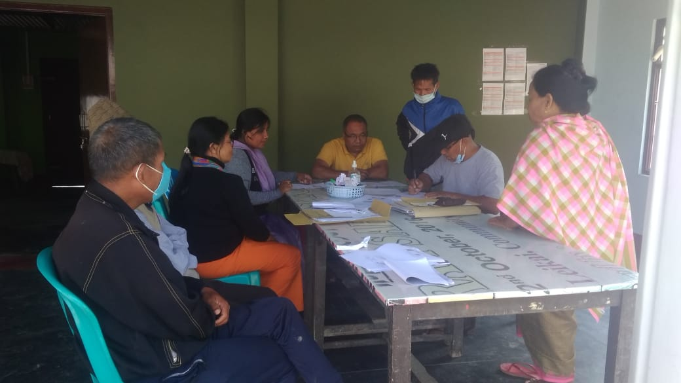

**COVID TESTING**

Club Members of Ngairangbam organized a Covid testing programe at Ngairangbam, our team was given the privilege of assisting the programe. Altogether 19 individuals showed up for testing and out of the 19 individuals who tested 9 were found positive with Covid 19 (6 female and 3 male).

**REMEDIAL COACHING**

The Nehru Yuva Kendra, Imphal West contacted the Remedial Coaching Centre, Maklang, for a Social Service Campaign under Swachch Bharat Mission (Clean India), 21 children from the Coaching Centre took part at the Social Service conducted on the 14th of Oct 2021.

Remedial Coaching Centre at Maklang conducted examination for students at the Centre on the 28th of Oct. the Centre is planning to conduct at least one examination for all the students once a month as the annual examination of all the schools will be approaching.

Numbers of children at Yurembam Remedial Coaching Centre has increased during the month, most of the children are from 7th standard. The Coaching Centre at present is located at a Government run School at Yurembam. A teacher from the school is also taking an active role in teaching the children at the Centre.

**HILDREN RELATED ACTIVITIES and LINKAGES**

The team was able to identify 10 vulnerable children, some of which are orphan, and their grandparents are taking care of the children, some are victims of child labour. The team had nominated the children names’ for Sponsorship Scheme, from the Concern Department, through their concern DCPUs.

The team is also in the process of tracking and identifying children who during the pandemic had missed their admission at schools. The team is planning to have an interface meeting with the school authorities for their admission if the need arise.

**BRIDGE COURSE**

In collaborations with the Remedial Coaching Centres’, private coaching Centres’ and through Online Classes the community Teachers for Bridge Course is carrying out the Classes with the Children of different villages. The community teachers are providing guidance to the children with their syllabus and the subject concern with an aim of evaluating their weak subjects or lessons.

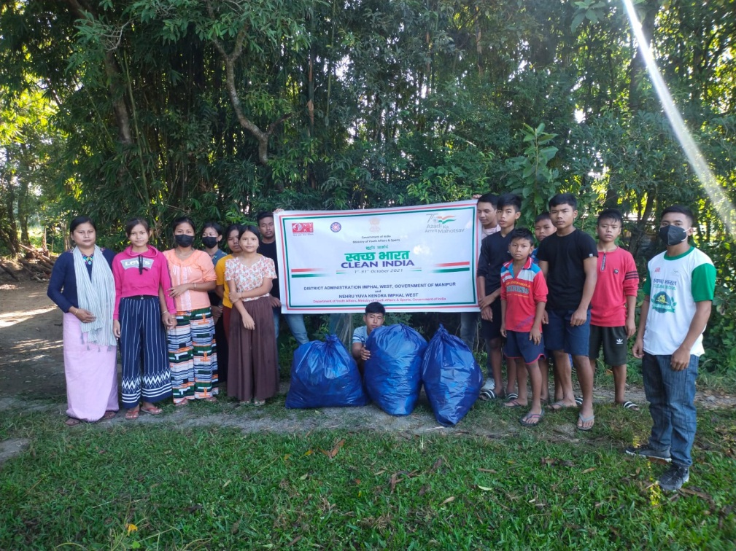

Children of Remedial Coaching Centre, Maklang at the Social Service Campaign organized by Nehru Yuva Kendra, Imphal West.

**VHND Programme with AAA**

The team participated at 4 VHND programme conducted at 3 different villages.

1. 8th of November 2021 atSalam, altogether there were 24 participants, 6 ASHA workers and 18 others from Women Organisation from the locality. Topics discussed during the programe were Covid Awareness and other illnesses which affects children at their age for e,g Cold, Diarrhea, etc
2. 13th of November 2021, at Maklang, 1 ASHA Worker, 1 Anganwadi Worker, 5 Pregnant Women and 5 Lactating mothers participated at the programme.Immunisation was the topic of the programme. It was informed to us that 1 lactating mother received PMMVY benefits, and another Lactating mother had applied for JSY and JSSK.
3. 15th of November 2021, at Maklang, 6 Pregnant Women, 8 Lactating mother, 1 ASHA, 1 ANM, 1 AWW participated at the programme. Besides the general information about about child care, we from CRY inform the participants about the Sponsorship Scheme, and the eligibility criteria for selection of children for the scheme. The participants were asked to inform us if they know any children eligible for the scheme.

**MEETINGS**

A meeting with ASHAs of Yurembam was held on the 17th of November 2021 and had a brief discussion on Vaccination, it was learnt that most of the people of the area had already been fully vaccinated.

Meetings with parents for collection of documents for Vulnerable Children for applying Scholarship Scheme were done on the 15th and 16th of November 2021 at Tharoijam and Salam respectively.

On the 22nd of Nov. a meeting with the Medical Officer of PHC Khumbong was held, with regards to the one day Capacity Building Programe on Child Rights.

26th of Nov. our team member met the District Child Protection Officer, Imphal West, collected information on Sponsorship Scheme for Children and also our team members inform the officer about the various challenges, the team faced while collecting documents as most of the families didn’t have proper or adequate documents to meet the criteria for applying for the scheme.

**CHILDREN RELATED ACTIVITIES**

**Life Skills Programes for Children Collective Group.**

Life skills programe for children were conducted at Maklang on the 3rd of Nov 2021. Altogether 20 children, 12 Female and 8 Male participated at the programe. The programe covers the basic information on Child Rights and Child Sexual Abuse. The programe was conducted in an interactive manner children took active participation in the programe

A similar programe was conducted at Tharoijam on the 14th of November, on the occasion of Children’s Day. The children were made aware of the significance of the day and why it is celebrated. Later the children were made to do activities like.

**CAPACITY BUILDING PROGRAME**

A 1 day Capacity Building Programe on Child Rights for ASHAs, AWWs workers and ANMs was conducted at the office of the Wide Angle Social Development Organisation, on the 25th of November 2021, where altogether 45 ASHAs, AWWs, and ANMs participated in the programe. A detailed report of the programe is as follows:

ONE DAY CAPACITY BUILDING OF AWWs, ASHAs AND ANMs ON CHILD RIGHTS

Report on a One Day Capacity Building of AWWs ASHAs and ANMs on Child Rights organized by the WIDE ANGLE SOCIAL DEVELOPMENT ORGANISATION, Sagolband Moirang Hanuba, Imphal West held at the Office of the same on the 25th Nov 2021. Altogether 45 AWWs, ASHAs and ANMs participated in the Programme.

Resource Person of the Programme:

1. **Montu Ahanthem**

Secretary, Wide Angle Social Development Organisation

Former Member, MCPCR

**Topic**: History on Child Rights and POCSO

1. **Keisam Pradip Kumar**

Former Member, MCPCR

**Topic**: Adoption

1. **Thiyam Rajkishore**

Chairperson, CWC, Imphal West

**Topic**: Role of Stakeholders in Child Rights.

The programe started at 11:00 am, the Project Coordinator, CRY Nanao Laishram gave the welcome address to the participants.

The first session was conducted by our resource Person Shri Montu Ahanthem, the session gave an introduction on Child Rights, formation of UNCRC and the role of Civil Society Organizations’ in bringing a change in the system by addressing our grievances and advocating for a reasonable and better solution for a problem in an International Platform.

Further, the session continue with a brief introduction on Prevention of Children from Sexual Offences (POCSO). The session explains what POCSO is and how sexual offences are described in the Act. The importance of our role as a member of a society is, in prevention of such cases by reporting on time and keeping a vigilant eye on our children as a parent was explained during the session.

The role played or supposed to be played by the stakeholders in the matter was also elaborated by the resource person.

The second session of the day was conducted by Shri Keisam Pradip kumar on Adoption.

The session explained what adoption means,

Types of Adoption (Legal and Illegal)

Criteria required for by a potential parents while adopting a child (Health, Financial conditions, Age etc.,) and the rights of an adopted child, and also who are the children, whom we can adopt, here the resource person explain what does it mean by an abandoned child and a surrendered child and the condition where the parents can reclaimed the child after being surrendered)

Misconceptions regarding adoption and the kind of adoption prevalent in our society were discussed during the session. The resource person enlightens the participants on legal and illegal adoption, and how illegal adoption can affect the child in future.

Shri Thiyam Rajkishore, took the last session of the day, he spoke on the role of various stakeholders in protecting the rights of a child. He started with the functions of Child Line, how it is operated and how we can help a child in distress, and also how we as a general public can report about a child or issues related to a child, like child labour or child marriage with just a phone call.

Roles played by the Child Welfare Committee, Juvenile Justice Board and District Child Protection Unit in safeguarding the rights of a child were also explained to the participants. Sponsorship Scheme by the Government where a child can apply for his/her studies, where and how to apply for the scheme was also made known to the participants.

The resource person furthers sheds lights on the adoption process existing at present. Function and roles of Specialized Adoption Agency (SAA) was explained, and also about the Child Adoption Resource Information and Guidance System (CARING) an online portal where the Prospective Adoptive Parents (PRP) registered them and wait for their opportunity or No. to choose a child of their preferences.

The programe ended with words of appreciation by the Project Coordinator, CRY Madam Nanao Laishram, to all the participants and the Resource Persons.

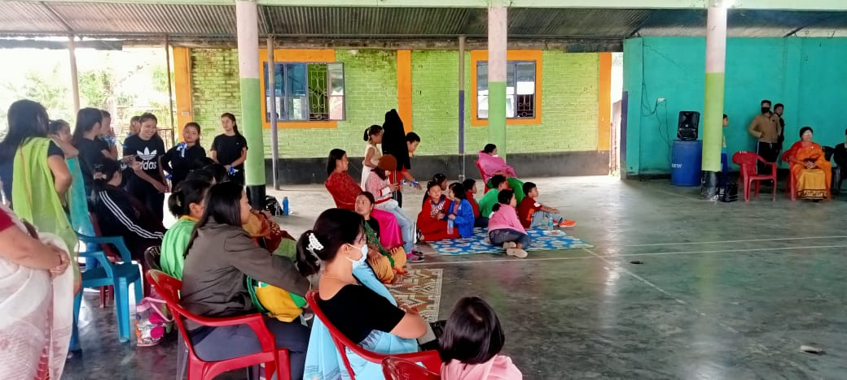

A children’s Programe , held at Patsoi Part III

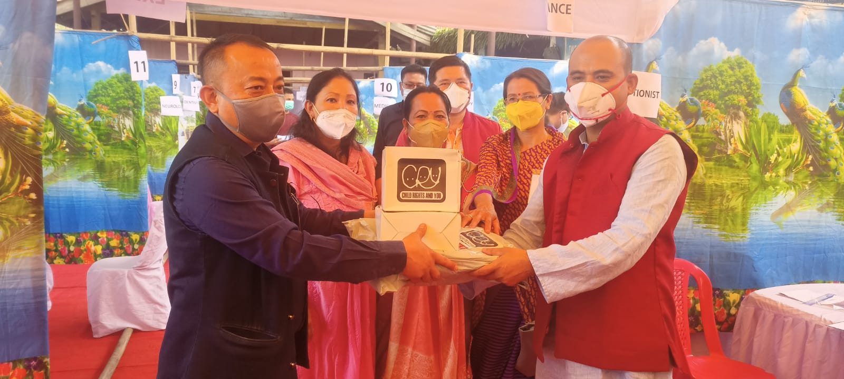

Mask Donated during a Health Camp

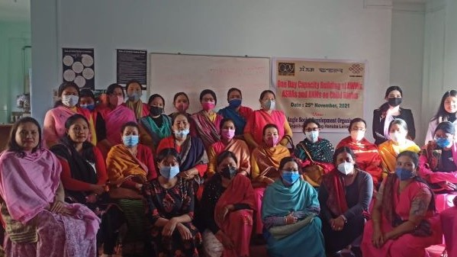

One Day Capacity Building of AWWs, ASHAs and ANMs on Child Rights

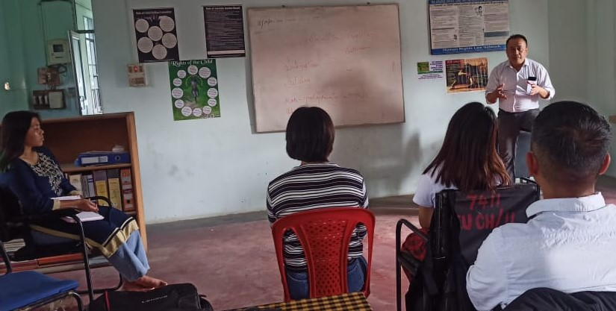

Orientation of Staff by the Secretary, Wide Angle Social Development Organisation

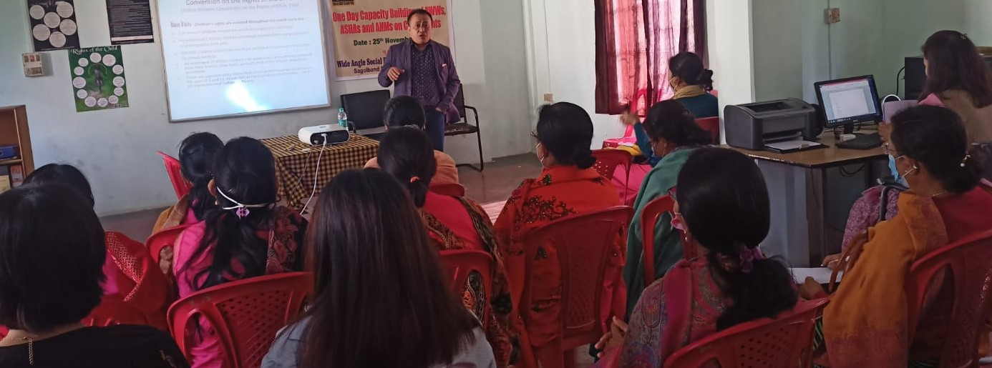

Session on History of Child Rights and POCSO Act by Shri. Montu Ahanthem

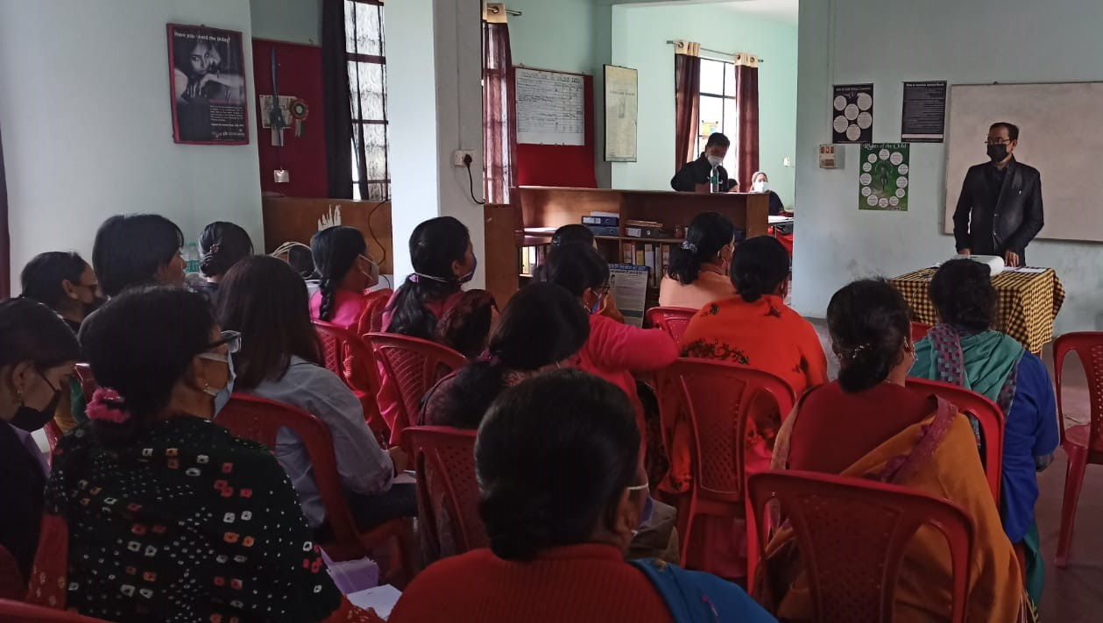

Session on Adoption by Shri Keisham Pradip Kumar

**PROGRAMME on VHND with AAA**

Altogether the team participated at 6 VHND programe during the Quarter. Details of which are as follows:

7th of Jan 2022, at Ngairangbam Village where, 17 women including 3 Anganwadi worker and ASHAs, 4 Lactating Mothers, 6 Pragnant Women and 6 Meira Paibis attended the programe.The team had a chance to take a session on nutritional requirement of pregnant women and lactating mothers and also the importance of Nutritional food/Diet, to the group.

12th of Jan 2022, at Maklang where 16 women participated in the programe which includes 6 Lactating Mothers, 5 Pregnant Women and 5 Meira Paibis. Our team took the opportunity to explain to the group about the Kitchen Garden Project, its importance and objectives and encourage them to participate in our programs as and when it is organized in their area.

9th of Feb 2022 at Maklang, the programe had 15 participants, with 1 ANM, 2 ASHA workers, 4 Lactating Mothers and 5 Pregnant Women. A topic discussed during the programe was on preventive measures from Covid19.

8th of February 2022 at Salam, 6 Pregnant mother, 5 Lactating mothers, 1 ASHA Worker, 3 Anganwadi Worker, 2 ANMs, 2 Local club members and 16 other women from self-help group and Meirapaibi. The team from the Kitchen Garden Project had the opportunity to interact with the participants where we spoke on the importance of good and nutritional diet during pregnancy.

7th of March 2022 at Ngairangbam, altogether 6 Lactating Mother, 5 Pregnant Mother, 1 ANM and 2 ASHA workers participated at the programe. The programe talks about the benefits of Breastfeeding and Immunization for children.

8th of March at Salam, the programe had 45 participants, one of the main attraction of the programe was the speech by Dr. Wanglen, M.O (In charge) of PHC Salam, on the topic ‘Prevention of STI’ in women.

**MEETINGS with VCPC**

Theteam after getting information, that at Moidangpok Awang Leikai which is a residential area and where a private schools is also located,a private company has installed 2 stone cursers, which is affecting the health of all the people residing in the area and also creating noise pollution due to which the school is having a hard time operating. The team had a meeting with the members of VCPC of Moidangpok on the 16th of January 2022 to look into the matter. The team is planning to take the matter to the Manipur Commission for Child Rights as well to the National Commission for Child Rights if the need arises.

**Participation and involvement of VCPC on kitchen garden project undertaken by CRY.**

The team rendered help to the staffs of kitchen garden project undertaken by CRY, We support them in conducting meetings with the VCPCs and Local Club members for effective implementation of the project. The selection of beneficiaries were also mostly from our project area villages.

**VACCINATION**

Meeting was held with the MOIC of Salam PHC regarding Vaccination programe, collected data for the same. The MOIC stated that even though vaccination for children age above 15 is already in progress, hesitation still exists and very less children came forward for vaccination.

From the data collected we are able to identify 35 children age under 15 years who got vaccinated.

**CHILDREN RELATED ACTIVITIES**

LIFE SKILLS EDUCATION TRAINING FOR CHILDREN

A 3 days training programe on ‘***Life Skills Education Training’*** for childrenwas organized by Wide Angle Social Development Organisation and held at Patsoi Tulliyaima Century Club from 11th to 13th of January 2022, with 35 participants from different villages of our project covered areas.

The training was a theory cum activity based, topics includes: Awareness of self, Stress Management, Problem Solving, Interpersonal Relationship Skills, Developing empathy, Decision Making and Communication Skills.

A ***Drawing competition*** was held with 35 children (20 male and 15 female) at Remedial Coaching Centre, Maklang. A Pencil Box and a note book for 1st position, a Pencil Box for 2nd and a note book were gifted to each and every child who participated at the competition.

Meeting with VCPC of Moidangpok villages was held on the 18th of Feb, to discuss on the ***Sponsorship Scheme*** for children. The VCPC members were made aware of the criteria for applying the scheme. They were entrusted with the responsibility for identification of children to apply for the scheme and also 10 Scholarship forms were handed over to the members for future use.

An awareness and sensitization programe on ***Child Marriage*** with the Anganwadi Workers along with VCPC members of Ngairangbam was held on the 24th of Feb at Ngairangbam

Our Programe coordinator, Madam NanaoLaishram was felicitated as a Guest of Honor by the VCPC Ngairangbam at the Block Level ***Inter Youth Sports Meet*** held from 11th to 13th of Feb at WSC Playground Ngairangbam Village, the Meet was organized by Western Sporting Club in Association with Nehru Yuva Kendra, Imphal West. Children from Yurembam who were receiving football coaching/training from our Coach participated at the said Sports Meet. Altogether 16 children from Yurembam and 20 children from PatsoiYaorang are presently receiving Football Coaching under our physical Instructor.

A field visit was conducted by the team at Uripok Ahanthem Leikai after a news report was published in a local newspaper claiming that 2 boys saved a younger boy from drowning at a local pond. The news report was found to be authentic, after which the team made a ***recommendation*** to the Social Welfare Department, Manipur for Bravery Award of the 2 children.

On the 9th of this month Community workers visited Patsoi Part III and met Th. Gopeshori an Anganwadi Worker of the area and discuss on child related issues. She was made aware of the issues related to ***child labour, child marriage and CSA*** cases the team came across in our operational areas, and inquire if she had experienced such cases in her area of concern and also the team inquire if there she came across any child suffering from malnutrition

The team visited Patsoi Yaorang to meet 5 (3 boys and 2 girls) children and their parents on the 7th of this month. These 5 children were identified by the VCPC of the area as they work as ***child labour***, gathering food waste from the locality for piglets and were school drop outs. We tried to make the parents understand about the situation and that they are violating the basic rights of the children. Effort were made to convince the parents to enroll their kids to school and offered our help in the process.

On the 13th, the team made a similar field trip at Tharoijam where we met 2 children and their parents. The 2 children ***drop out of school*** due to financial constraint in the family. The team convinced the family to let the children continue their studies and offer our help in any way they need in the field of education. The parents were really happy with the visit and were motivated to get their child get admitted in the nearby Govt. run school.

The team visited Ima Children Home situated at Keithelmanbi on the 3rd of January 2022, we met the Secretary of the home and had a discussion on the working of the home, its fundings and administration and also we interact with the children staying there.

Field trips were made to Luker and Moidangpok village on various occasions for identification of children for Sponsorship Scheme under ICPS and collection of Documents for the same. We were able to apply for 4 children, 2 children from Luker and 2 children from Moidangpok village.

SENSITIZATION PROGRAME

A one day ‘Sensitization for Adolescent Girl on Reproductive Child Health’ was organized by Wide Angle Social Development Organisation, and held at Mind Empowering Centre, Patsoi Part III on the 27th March 2022. The programe was sponsored by CRY.

Resource Persons of the Programe:

1. Mala Lisham

Programe Officer (ICPS)

Social Welfare Department,

Government of Manipur

1. Nanao Laishram

Programe Coordinator, CRY

1. T. Sunitibala Devi

MIS Coordinator, CRY

1. Lhingjachin Haokip

Member, Juvenile Justice Board

Senapati District

**PROGRAMES WHERE THE TEAM ASSISTED**

AWARENESS

An awareness programe on ‘Health hazards due to calcium deficiency’ was held at Tharoijam Mayai Leikai on the 17th of this month. The programe was organized by the PHC, Salam and the MO of the PHC, Dr. Heigrujam Wanglen gave the speech on the topic. Our team participated and assisted in mobilizing the participants for the programe.

IMMUNIZATION

Another programe was the Polio Immunization Programe held on the 24th at Tharoijam Community Hall. Altogether 50 children, 30 female and 20 male children got immunized on the day.

**HEALTH CHECK UP FOR ALL**

A health checkup programe was conducted by ASHA workers namely Ahongshangbam Premita and Akoijam Ritipyari of Maklang, and was held at Maklang Makha Leikai, from 12- 20th of March. Blood pressure level, RBS, Blood group was checked for 50 individuals who came for the checkup. Our team members on the request of the ASHA workers assisted in mobilising the villagers to come forward and gain the benefits of the programe.

POSHAN PAKWADA

An ongoing event of Poshan Pakwada under POSHAN Abhiyan is being held at Yurembam Awang Leikai which will conclude on the 4th of next month. Our team members are taking active part in the event.

**ONLINE TRAINING**

The team participated on an online Training on ‘Child Centric Disaster Risk Reduction’ held from 24th – 26th Feb 2022 organised by the National Institute of Disaster Management in collaboration with CRY.

**CAPACITY BUILDING / ORIENTATION of STAFFS**

A one day capacity building programe for the staff members of CRY, staffs of Kitchen Garden Project, Teachers of Remedial Centre’s and teachers of Bridge Course Project under CRY. Project Coordinator, Nanao Laishram took the sessionsfor the day. She explained the roles and responsibilities of each and every staff members of each projects, and what are the expected outcomes from the staff members and the overall projects.

**REMEDIAL COACHING CENTRES**

Remedial Coaching Centre, **MAKLANG**

Total No. of Students registered at the Centre: **70**

Number of regular students: **40**(22 male and 18 female child)

Classes: Class 2 to 8

Class timings: 7 am – 9 am

Subject Taught: English, Basic Arithmetic, Spellings, Word Meaning, General Knowledge and Current Affairs

Assessments Type: Written and Oral.

Remedial Coaching Centre, **PATSOI**

Total No. of Students registered at the Centre: **50**

Number of regular students: **36** (15 male and 21 female child)

Classes: Class 4 to 8

Class timings: 6 am – 8 am

Subject Taught: English, Basic Arithmetic, Spellings, Word Meaning, General Knowledge and Current Affairs Assessments Type: Written and Oral.

Most of the student who attended the centre at first was very weak in studies, some of them were even finding it hard to write their names in English. Teachers of the centre had to start from the basics. As the classes were held at the same time for students from different classes, different strategies were applied to meet the need of the students so that each and every child benefits from the class or any session.Since the beginning of the centre, assessment for the students has been conducted thrice, and improvement had been observed for most of the students.The number of students registered and students attending classes regularly differ as most of the school has already reopened and students of higher classes have started to attend school regularly.

**Advocacy Meeting at Sagolband Moirang Hanuba**

A One day Advocacy meeting was held on 17th September 2021 organized jointly by Wide Angle Social Development Organization and Semgatgat Saghatpa Committee, Moirang Hanuba. The event was attended by ASHA worker Miss Binokumari Devi, Mr. L. Jillasana Singh, Secy.of the said Club and Member Mr. Th.Radheshyan, Montu Ahanthem Secy. Wide Angle and Staffs of Wide Angle as well as KPs and Spouses and other participants. 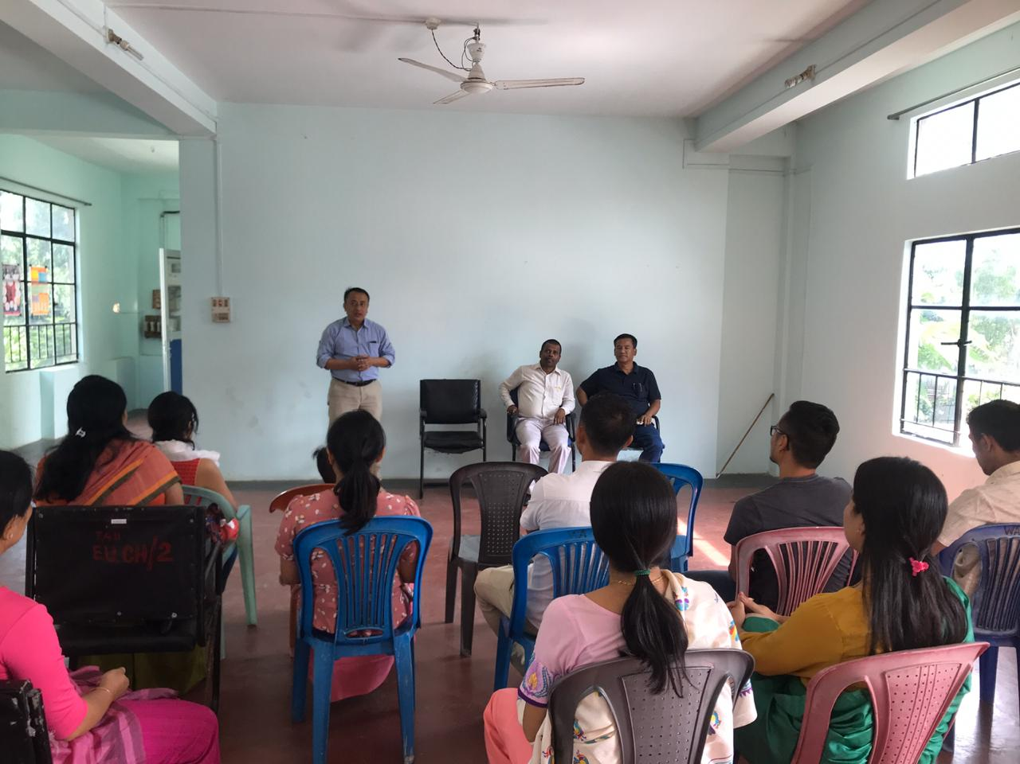

The welcome address was given by the ***Chief Functionary of Wide Angle Mr. Montu Ahanthem*** he gave the overall objectives of the program and warmly welcomes all the participants. Then ***Project Manager Mr. A. Robi Sharma*** facilitates the program by elaborating on the challenges faced by our staff in outreaching to the community, to minimize the level of trauma among women and children cause due to HIV/AIDS and to eliminate stigma and discrimination from the society. Activity related to reducing harm, stigma & discrimination i.e. organize the activity related for children affected by HIV/AIDS and to provide them space in engagement with the broader society in Manipur and to avail the services which is provided by Wide Angle through MSACS.

After that Mr. Lakpoklakpam Jillasana Singh, Secy. Of the Club shared that he is very happy to be part of the program and appreciated the services provided by Wide Angle but lack of information and awareness their localities suffer a lot and it is a privilege to attend this program and hope the entire participant will gain immense knowledge on HIV/AIDS prevention program.

This was followed by some discussion on the topic “**The issue of drug user and its impact on the society as well as the rights of drug users “**. The participant includes Wide Angle Staffs staff some KPs, spouses and general people of Moirang Hanuba and Kolom Leikai. ***Mr. A. Robi Sharma, Project Manager WA*** state the harms of drug use and the strategy to control it, about Demand reduction, Supply reduction and harm reduction the effectiveness and importance of harm reduction. Some of our KPs express their woes and lack of knowledge others express their hate and misunderstanding. One Family member said that she is really fed up of his son’s behavior and very sad. ***At the conclusion*** the facilitator explain that it is best to stop drug use but even if they cannot they should follow the safer practice to maintain their health and to avoid the prevention and control of HIV/AIDS and Wide Angle will provide any kind of help which is within their limitation and people’s co-operation and help in needed. One should respect and understand the feelings and rights of people whether they are IDU’s or not. Because IDU’s are also human being and they should be respected and give time as well as encouragement to change their habits by giving proper treatment. The discussion was wind up having a light refreshment altogether

**TYC, Club, Patsoi- 3, Imphal West**

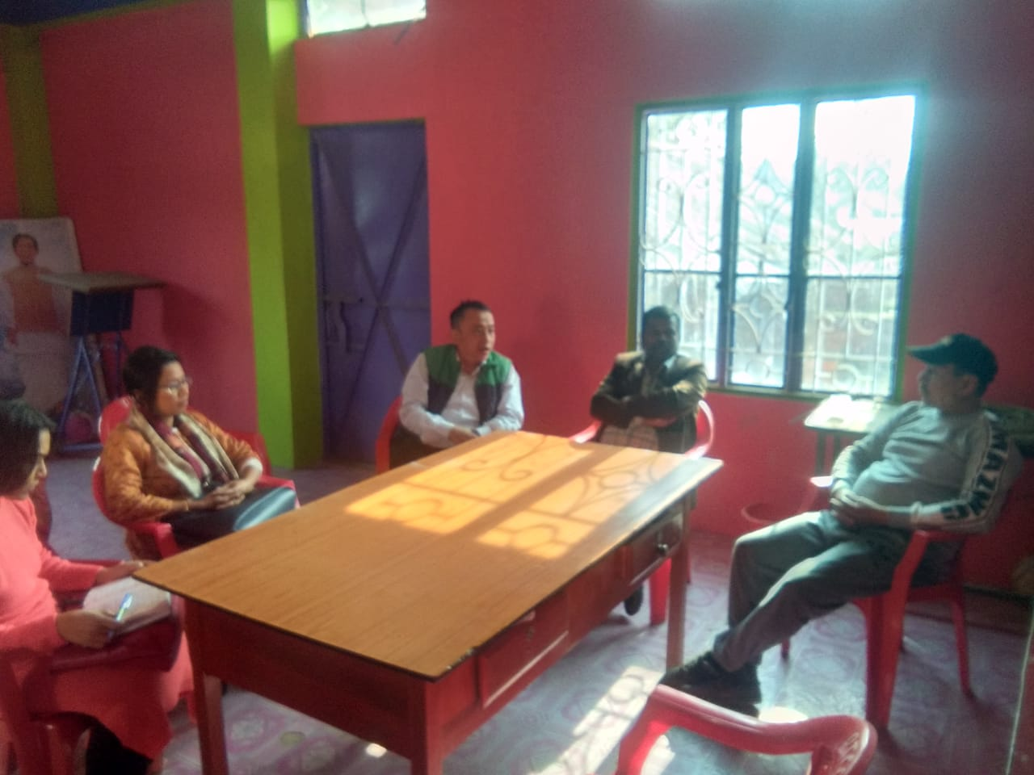A One day Advocacy meeting was held on 27th November 2021 organized by Wide Angle Social Development Organization and Tulhaleima Youth Club, Patsoi Part-3. The meeting was attended by Mutum Dhanachandra Singh ,President (TYC)and Montu Ahanthem Secy, Wide Angle, Sagolband Moirang Hanuba,and Konthoujam Ongbi Sanatombi Devi, President Apunba Meira Paibi, Patsoi and members of the club and staffs of Wide Angle.The welcome address was given by the *Secy****.*** Of the club, Mr. Dinesh Singh warmly welcomes all the participants. Then he shared out challenges faced by the club in the interest of the community issues created by Injecting drug users. The clubs been working to eradicate the drug menace since last one decades but positive response from the individual level was very low. Every month they are facing different unbearable family crisis and discriminating among each others.

“**The issue of drug user and its impact on the society “**. ***Mr. Montu Ahanthem, Secy. Wide Angle*** shared that Supply reduction and demand reduction takes a major role to combat the drug problems. As we all know that drugs were sent through different routes to our state. Moreover cultivation of drugs plant known as Poppy Plant in many hill ranges were popular in our state. It was reported that such poppy grains are illegaly manufactured in valley area without proper industrial knowleged which affects our community severly. Our goverment tried to minimized the poppy plantation and supply of drugs with collective efforts. Due to high value of bussiness sector this work is not stop by some sections of our soceity.

Meanwhile, our goverment also paid more efforts on harm reduction by encouraging diiferent NGO’s under Manipur State Aids Control Soceity, Manipur. Severeal services were deliverd through community as well as certain section of our soceity to minimize the drugs issues. Introduction of Opoid Substitution Therapy in the NGO level reulting out a great boons to the community for those failed to take drug treatment programme in rehabilitation centre. Anyone can take this oppourtunity to stop using without any cost from himself and family. Under this treatment they can do their normal work and higher chances of attaining maintream. He suggested to the club member and local stakeholders to connect our organization which stands for drug using community.

As a closing remarks, the Joint Secretary of the TYC club thanks to all for having a milestone discussion in respect of the drug users community. He commited that they are ready to consult or refer their brothers in time of any drug related issues.

After having a light refreshment, the advocacy meeting wind up at 12:45 p.m

HEALTH CAMP 25th March 2022

As an ongoing process of project activity a one-day Health camp was organized by the Wide Angle Social development Organization (TI project) at our Project (Patsoi DIC)on dated 25th March 2022, it was organized under the sponsorship of Manipur State AIDS Control Society (MSACS). The program was started at around 11.00am with a registration of all present participants. During the meeting all-together 31participants including spouses and children from and around the sites were present.

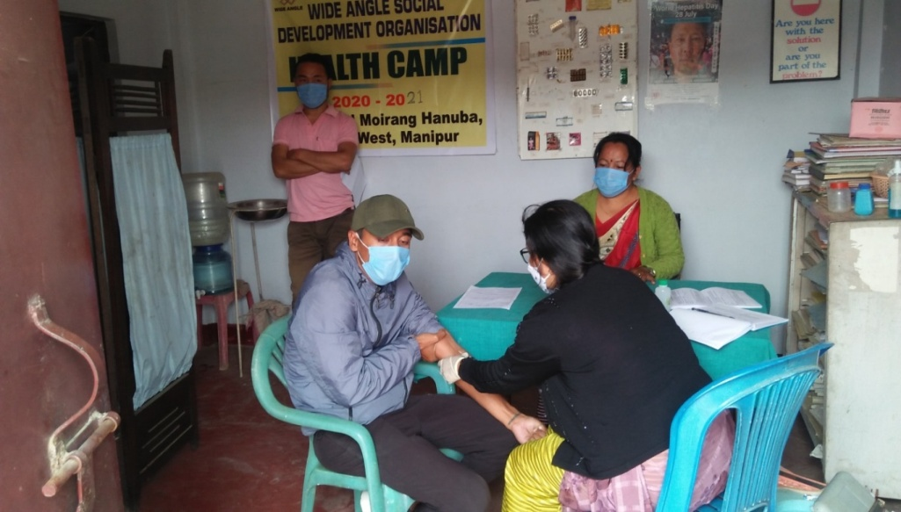Just after completion the registration of all the participants, the main program was started at 11.00 by A. RobiSharma, Project Manager, Wide Angle facilitated the program by highlighting all the related issues of drug use with HIV/AIDS and problems faced by the staff at the time of service delivery. He highlighted with example the importance of involvement of community member at the time of service delivery and having acknowledged about the project activity to prevent HIV/AIDS, only means to avoid any inconvenience and misunderstanding between the service provider and local community member. He further emphasized to the participants as mandatory of having knowledge of HIV/AIDS as an only means to prevent HIV/AIDS and we were focusing to conduct for each IDU’s of the sites to have HIV testing and ready to cooperate to access all the available service at DIC. He finished his words by approaching towards the participants to understand the problems of HIV/AIDS and to extend support to prevent and control the epidemic of HIV/AIDS by initiating from our locality.

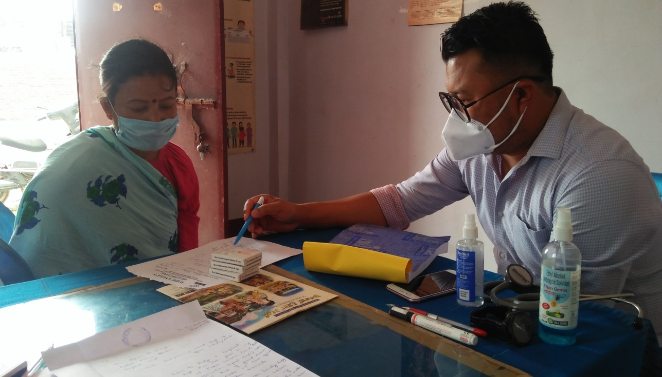

At around 12:30p.m, the medical team of MLSS, Khuyathong, Imphal West conducted HIV testing through proper counseling. Altogether 37 persons from different sites participated the testing. The Doctor also conducted routine medical checkup for those who are medically complained. Some children also had given Vitamin syrup by our organization.

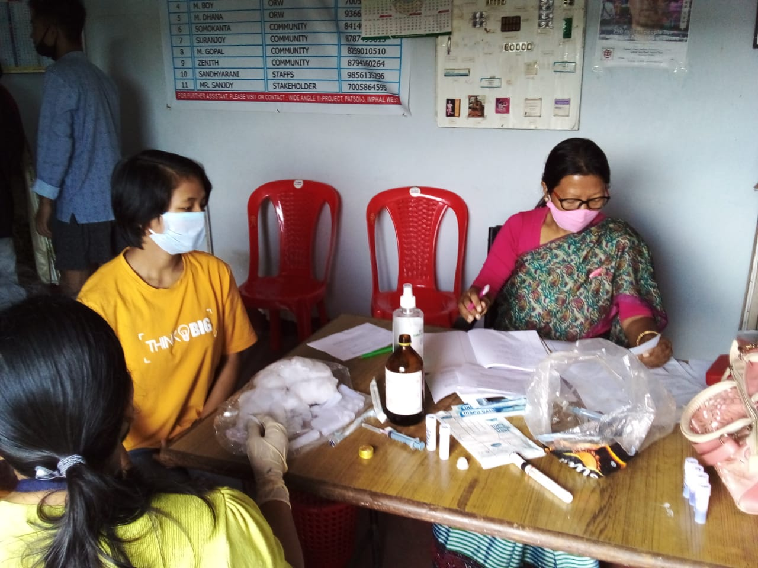

Mr. K. Tinku Singh (ORW) gave the vote of thanks of the program me. He expresses the satisfaction to the present members about the involvement as a participant as well as the staff who had worked hard to make this program a grand success. He also express the appreciation those who extend support and making involvement himself in this program.

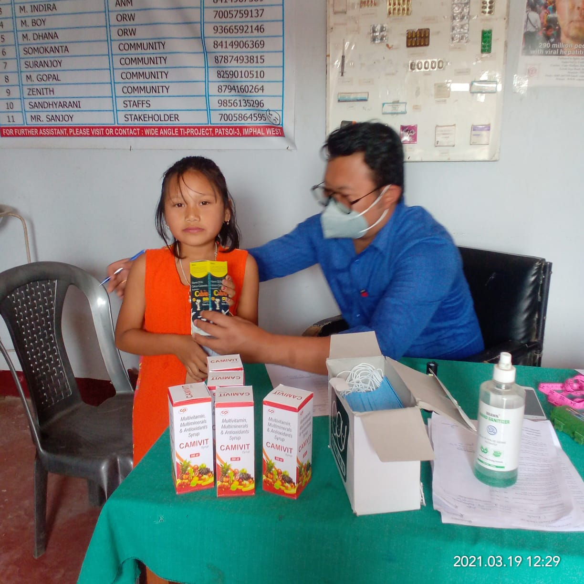

At around 02:30p: m, we had a light refreshment and the programmed was wind up.